Dani Black
Sociology of Prisons
10/27/19
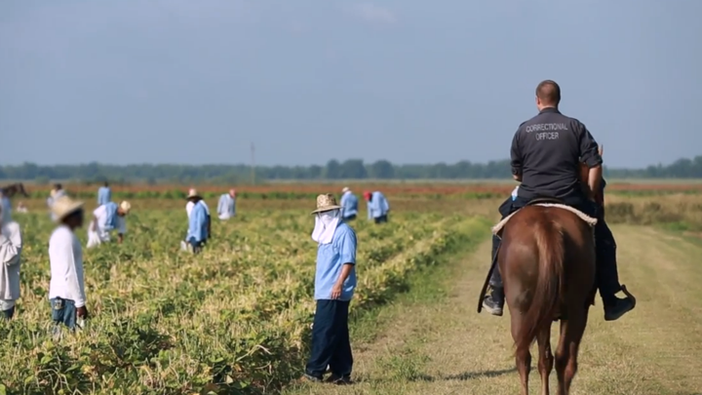
The central theme that Robert Perkinson builds upon in ‘Texas Tough’ is the reinvention of slavery in the correctional facilities. The image I chose for the project shows an armed guard on a horse watching over inmates working on a farm. The field in which the inmates work stretches over the horizon. The guard is white, while the inmates on the fields com from minority communities. The image is an illustration of a system more intent on capitalizing on the overflowing prisons than on rehabilitative efforts of their prison populations.
The thesis in the book ‘Texas Tough’ is the mistreatment and lack of abiding by civil rights and liberties of inmates. Robert reiterates freedom as the founding creed of the American Republic. As a nation, he briefly describes how the United States history is rich with fights for liberty and equality among citizens. However, the entire book then begins to illustrate how such a heritage is lost on the inmates in correctional facilities. The civil war and the emancipation proclamation are just items from the past. The current structure illustrates moving black towards minority victimization. The numbers are much starker in Texas, where ironically, it is the home of significant politicians to ascend to the highest public office. Perkinson details the milestone in the United States covered from the age of slavery to the period of imprisonment.
Perkinson highlights that African Americans in society today are twice more likely to go to prison as they are to join colleges. The statistical evaluation also includes that they are almost seven times more likely to be incarcerated as compared to the whites. Perkinson also evaluates that in 35 years leading up to 2000, the incarceration rates in the country rose by 600%. The same evaluation at the same time for Texas is 1200%. It is due to this fact that the author claims that Texas is the hub of imprisonment in the United States. The author also assumes that the government-run plantation and chain gangs ran on subjugation, without giving specific facts. The author also reiterates that the penal system in Texas and the south is less considerate of rehabilitation.
Sociological imagination theory capitalizes on the relationships between the society and the individual, thus providing a broader view of how the community functions. The approach takes significant insight from the interactions and influences of different varieties and requires assessing the situation from an alternate perception. Robert Perkinson provides the reflection that governed the thought process of members in the south who lost the Civil War but still intent on retaining dominion over former slaves. The rationality chosen by the group assumed the law enforcement system whereby arrests for the blacks were high, and convictions very stiff. The assessment also holds for today, with more than 80% of the population indigent, and half of the inmates are illiterate.
Rational choice makes use of calculations to achieve a specific goal. The goals in this context are for personal fulfillment. Robert Perkinson highlights how government policies targetted the African American community. Such strategies include the tough stance on poverty, war on drug and abuse, and crackdowns. Other additional laws that confounded the current racial dilemma in the correctional facilities include the privatization of prisons and proponents for mass incarceration. Both are integral parts of making profits.
Utilitarianism moves beyond the interest of the individual and accounts for the benefit to others. The theory bases actions as either morally right or wrong based on the consequences witnessed. Robert takes account of the solitary confinement actions by the Northern correctional facilities as victimization. He, however, restates that the attempt, though not ethically right, was based on the intent to rehabilitate. Robert also highlights the potential benefits of drug treatment for inmates in Texas.
The just-world theory is a hypothesis that the world is just and people are bound to receive what they deserve. The approach highlights the rights and wrongs one has committed in the evaluation of what is bound to happen to them. The specific entries of the different victimization by the prison system make us wonder if any reform would capably swipe the stain. The cultural indignation of the penal system illustrates the lack of responsibility, which brings to light what fundamental change may be adequate to move the system to one of rehabilitation.
Functional theory evaluates society as a complex system of interlinked parts whose design explicitly meets the social and biological necessities of individuals. The thesis should have included insights from the evidence indicating the federal and state policies that target reforms towards rehabilitation. Another integral missing component from the argument is the probability of lasting change, and how to come about it. However, the book does portray the creation of the Northern model.
The perception behind conflict theory places significance on the distribution of powers, resources, and inequality. Robert Perkinson presents a decade by decade account of alteration in the penal system that enhanced victimization of the African American community. The details also include policies invoked by politicians hailed as the agendas to reform the penal system. The book also highlights how Texas, as the hub of the prison system, has capitalized on prisons and mass incarcerations, which serve as additional government and private resources.
Robert Perkinson describes throughout the entire book, the discrepancies that allow for inequality for minority communities. A specific change in policy that would encompass Perkinson’s opinion from the book is equality in treatment. The system would demand equal treatment for all inmates, who will all be paid a certain fixed amount for the chores and tasks while under rehabilitation. The policy would also aim at creating a society inside the prisons. Such a change would make it easier to instill educative and reformative practices.

References
Perkinson, R. (2010). Texas tough: The rise of America’s prison empire. Metropolitan Books.

